NCAA 26 Skill Points Model
Alex Swanner 10/30/2025 linkedin.com/in/alexswanner/

Executive Summary
The purpose of this research was to build a model to accurately predict the amount of skill points a player would have in total on the “Training Results” screen in the “Dynasty” game mode from EA Sports College Football 26. EA Sports College Football 26 is a college football video game available on platforms such as Xbox and PlayStation. In the Dynasty mode, you can control a team or teams across multiple seasons starting in 2026. You play games, recruit players, fire coaches, build schedules, and much more. In the offseason, there is a week called Training Results. It is during this week you are able to see how many skill points each of your players has accumulated up until now. Skill points are the method in which you can manually upgrade your players. Understanding the best way to maximize these skill points is key when it comes to building your team.
I built a multiple linear regression model in Excel and in Google Colab to predict skill points. I collected my data directly from the Training Results screen in the game. I manually typed in hundreds of entries into Excel. I listed names, positions, development traits, and coach skill point boosts that applied to each player. My current model, which consists of five hundred twenty-eight entries, has an adjusted R-Squared score of 0.932. This is strong predictive capability. With the assistance of generative AI (ChatGPT and Claude), I built a desktop GUI in Python where users can input a player's information to receive a prediction for their skill points. I also deployed the model as a web application using Streamlit, making it accessible to the Dynasty community with integrated data collection for continuous model improvement.

Introduction
In the world of EA Sports College Football 26, there are many game modes available. A fan favorite game mode is Dynasty. You can control one or many teams across up to thirty seasons. You can play by yourself, or in a shared Dynasty with friends. There are over one hundred teams to choose from; you can start with a big program such as Alabama, or a small program like Kennesaw State. You can use existing head coaches and coordinators such as Hugh Freeze or DJ Durkin of Auburn University; there are over three hundred real-life coaches to choose from. There is also the option of creating your own coach. Coaches are really important in the scope of the game mode. Coaches, along with players, receive points that you can use to upgrade them. There is a coaching tree that consists of different areas of expertise. Some examples are Motivator, Tactician, and Recruiter. Recruiter helps with recruiting; Motivator helps with player development, and Tactician gives direct gameplay boosts.
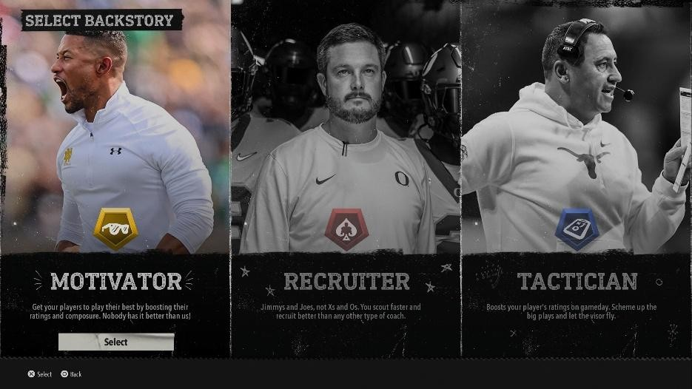
These three coaching abilities are the base abilities; when you create a new coach,
whether it is a head coach, offensive coordinator, or a defensive coordinator, you will select one of these abilities first. You start at level one and as you do things like sign recruits and go on win streaks, you earn skill points. With these skill points you can upgrade the abilities you have already purchased or try to purchase new abilities. Each of these main abilities has a tree of its own. The base three, Recruiter, Motivator, and Tactician, each have two parts. The first part of each of the base three abilities is all unlocked, and you unlock the second part by completing additional in-game goals. All of the trees within the abilities are tied to a position group. There are eight position groups in each ability. The position groups are as follows: QB, RB/FB, WR/TE, OL, DL, LB, DB, and K/P.
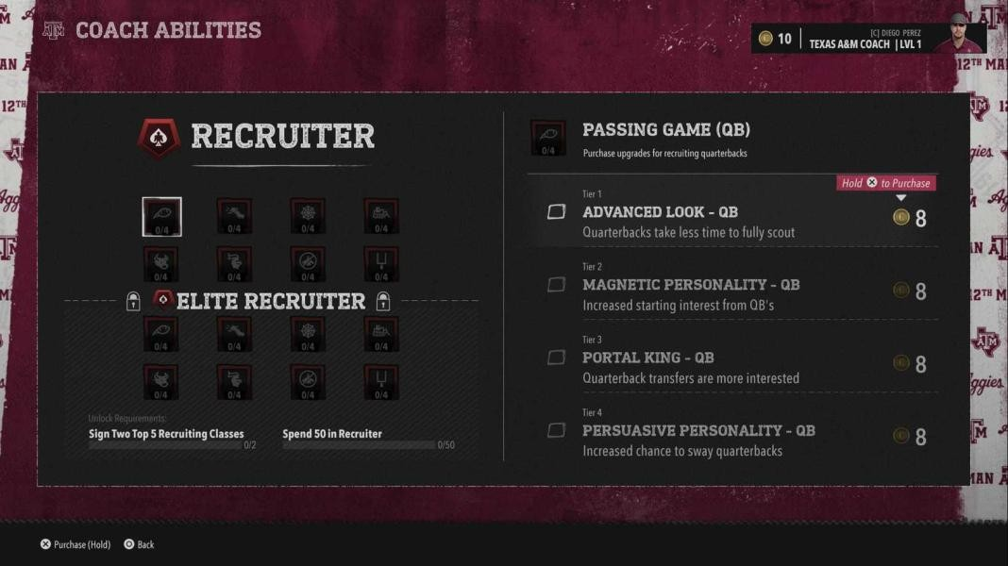

With each position group, there are four tiers. Each additional tier is locked behind the one before it, except for tier one of course. There are additional coaching abilities that will be able to be unlocked as you upgrade your coach. These coaching abilities are super important as they can
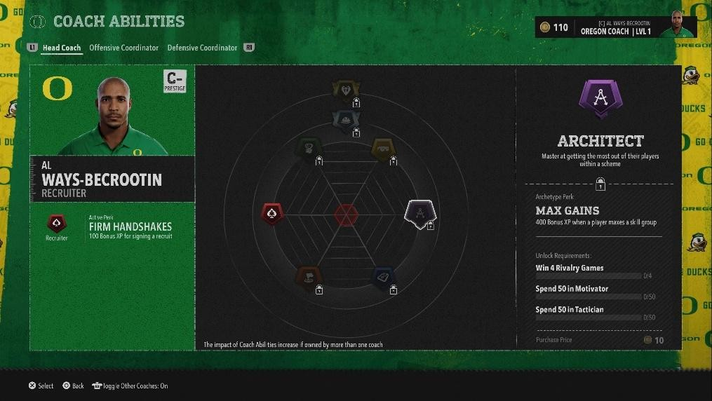
have a direct influence on how your players can develop. The two main coaching abilities with respect to player skill points are Motivator and Talent Developer. I will explain these later when I introduce my explanatory variables.
Maximizing player skill points is my favorite way to build my teams. Every offseason you will find out exactly how many skill points each of your players has to take advantage of. In last year’s edition of the game, you really did not ever see how many points they got. There was no way to manually upgrade the players. It was all done automatically, so as soon as the player had enough skill points to upgrade, it was just done by the computer. In last year’s edition and in this one, each player has “buckets” of attributes you can upgrade. For example, just about every player has a “Quickness” bucket that includes things like speed and acceleration. When you upgrade a bucket, at least one of the attributes in the bucket will be increased. Each bucket has a different cost associated with it. Some buckets are cheap, and others are expensive. It scales in that as you get closer to maxing out an attribute bucket, it gets more expensive. Also, it is important to know that not every bucket can be fully maxed out for every player. Each player has “caps” on their attribute buckets. For example, some players come in at the fastest they will ever be. They come in with a speed rating of ninety, and that is the best they can get. Other players can come in with a ninety-speed rating and be able to get all the way up to ninety-nine.
In this year’s edition of the game, you can manually upgrade players. This was a key feature many fans like me were hoping to see. This allows you to have more control over how your players upgrade and how you function as a team. Want to have a strong running game? You can make sure your offensive linemen upgrade their run block. Want to attack defenses down the field? You can upgrade your QBs’ arm strength. Getting these skill points for your players is one of, if not the best, ways to build your team. It is important for getting a competitive edge against your foes in online dynasties. Understanding what factors influence player skill points and building an accurate predictive model is the main focus of this research.

Data Collection Methodology
All of the data I used to build this model came from my own system, my own game, and my own Xbox. I manually entered five hundred twenty-eight entries into an Excel sheet. My data set currently consists of eight teams with about fifty players each. When I first got the idea to build this model, I figured I would just use a player set from a dynasty I was actively participating in. It was an offline dynasty that was with my favorite team, Auburn. I was about fifteen years into the future when I got the idea. It is important to note that this data set is unique in that it has the most coaching abilities applied to it. I made my own coach, Alex Swanner, who is level ninety, and neither of my coordinators ever left, so they too have a good number of coaching abilities. This is the source of my first team in the data set. I initially figured I would just add to the data set when I go to the Training Results screen every year, but I realized I would not want to get through the seasons that fast. I wanted new entries sooner than that. I decided on starting a new dynasty, selecting the current head coach, and simming to the Training Results screen. This is the method I used for most of the data collection. The last one hundred-twentynine entries are actually from the same team, Georgia. I got these entries from the same dynasty, and they are from two Training Results screens. They are two years apart. They would have been one year apart, but I made a mistake. On year one in the Training Results screen, I recorded my data and decided to sim to the next “Draft Results” screen. Here I recorded the players that were drafted from the team. This is important; I will explain later. I then went to the next Training Results screen to see how my players performed this season in terms of skill points. I come to find out that none of the skill points got spent, so this year two Training Results consisted of two years of skill points, not just one. I had to spend the skill points and then repeat the process. Sim to next year’s Draft Results screen, and then to the Training Results screen. I did two sets of entries with Georgia because I was lacking enough Elite players in my data set. They are hard to come by. With Georgia, I spent a season recruiting hoping to find Elite players to record information on. I needed more of this data to train my model better. I used these settings with each setup:

- Coach Firing: Off
- Injury: Off
- Wear and Tear: Off
- User Player Transfer Chance: 0
- Auto Progress Players: Off
- Quarter Length: 5 mins
- Default roster
- Offline Dynasty

Coach Firing was set to off so that I was not fired. Being fired would prevent me from getting to see the Training Results screen for the team I selected. I turned Injury and Wear and Tear off to prevent my players from getting injured. Injuries would affect their playing time which could affect their skill points. Transfer Chance is set to zero so that my players I wanted to collect data on would not leave. Quarter Length is not super important as I simmed all the games anyways. Quarter Length applies only when you are actually playing the game. I figured this was something good to keep constant though. Default roster and Offline Dynasty are also for controlling variables as well. In the start of the seasons, I took advantage of the pre-order bonus to get more coach ability points. You receive one hundred; I used these to get more of the key coach abilities to get further variation.
I used sources like cfblabs.com to find coaches with a good mix of Motivator and Talent Developer abilities. I first chose Clemson, followed by Michigan and Rutgers. These teams had a good mix of coaches with these abilities.
Finding coaches with these abilities was really important as these abilities are key variables in the models that I built. The variables in my models:
- Team- Team that the player plays for
- Name- Name of player
- Skill Points (Dependent Variable)- How many skill points the player had on Training Results screen
- Position- What position the player plays
- Year- Class of player, i.e. Freshmen, Sophomore, etc.
- Dev Trait- Development trait that the player has, direct influence on player development.
- Dev Trait #- Number assigned to dev trait to make a numeric column
- Snaps- Number of snaps player played
- HC_Moti 1- Tier three in part one of the Motivator ability, “[Position group] get an offseason training boost.” For head coach
- HC_Moti 2- Tier three in part two of the Motivator ability, “Increase all XP gains for [Position group].” For head coach
- OC_Moti 1- Tier three in part one of the Motivator ability, “[Position group] get an offseason training boost.” For offensive coordinator
- DC_Moti 1- Tier three in part one of the Motivator ability, “[Position group] get an offseason training boost.” For defensive coordinator
- HC_TD 1- Tier one of the Talent Developer ability, “Bonus XP for [Position group] when [Position group] are drafted.” For head coach
- HC_TD 2- Tier two of the Talent Developer ability, “Freshmen and Sophomore [Position group] progress faster.” For head coach
- HC_TD 3- Tier three of the Talent Developer ability “Starting [Position group] will gain XP faster.” For head coach
- OC_TD 1- Tier one of the Talent Developer ability, “Bonus XP for [Position group] when
[Position group] are drafted.” For offensive coordinator
- OC_TD2- Tier two of the Talent Developer ability, “Freshmen and Sophomore [Position group] progress faster.” For offensive coordinator
- OC_TD 3- Tier three of the Talent Developer ability “Starting [Position group] will gain XP faster.” For offensive coordinator
- DC_TD 1- Tier one of the Talent Developer ability, “Bonus XP for [Position group] when [Position group] are drafted.” For defensive coordinator
- DC_TD 2- Tier two of the Talent Developer ability, “Freshmen and Sophomore [Position group] progress faster.” For defensive coordinator
- DC_TD 3- Tier three of the Talent Developer ability “Starting [Position group] will gain XP faster.” For defensive coordinator
- XP Penalty- In the main menu there is a slider to penalize manual progression. Functions as a percentage, scales from zero to one hundred.

Development trait is a categorical variable, and in order to use it in regression I need it to be numeric. There are four unique traits: Normal, Impact, Star, and Elite. Normal is the worst and Elite is the best. I decided to assign a number to each development trait, 1 for Normal, 2 for Impact, 3 for Star, and 4 for Elite. There is not a variable for tier 3 of part 2 in Motivator for the offensive and defensive coordinators as I could not find a coordinator with this ability. Year is a really important variable as it is tied to tier two of the Talent Developer ability. It reads as freshmen and sophomores progressing faster. A tricky part of this is not knowing exactly how the game defines freshmen and sophomores. For the sake of this research, I included freshmen, sophomores, redshirt freshmen, and redshirt sophomores.
Also with year, on the Training Results screen, for every player it lists their new class. I decided to do a kind of minus one here. I wanted to see how they developed as the player they were for all of last season, not for who they literally just became. For example, if a player just became a junior, I want to see how they developed all last season as a sophomore. A tricky part of this was not knowing if they had just received their redshirt or not. For example, do I list a redshirt junior as a junior, someone who just got their redshirt, or as a redshirt sophomore, someone who got their redshirt before the season they just played? For consistency, I listed anyone who had RS in their name as someone who already had their redshirt. If I saw redshirt sophomore, I put redshirt freshman. Anyone listed as a redshirt freshman was just listed as a freshman though. Because of this, you will not see anyone listed as just a senior. If I saw senior in the game, I listed them as a junior. If I saw redshirt senior, I listed them as redshirt junior.
Instead of listing every single position, I lumped them together in a similar manner to the coach abilities. I combined FS and SS into just S. LB is MIKE, WILL, and SAM. OL is LT, LG, C, RG, and RT. DL is REDG, DT, LEDG. RB is HB and FB. I kept QB, WR, TE, CB, K, and P on their own though. For Talent Developer tier three, I defined a starter as more than three hundred snaps.
It is also important to know that at the end of the season a player can have their development trait increase. For the sake of this research, I just took the development trait that was displayed on their player card, the one it got upgraded to.
There are two variables I could have tried to include here. Two coaching abilities that do likely influence skill points. I did not include them in this study as tracking them would have been very difficult. One of the coaching abilities is called Architect. Like Talent Developer it has four tiers and eight position groups. Tier one of Architect reads: “[Position Group] earn an XP bonus for every three-game win streak.” Tier two of Architect reads: “[Position Group] earn additional XP for in-game goals.” Tracking either of these would have been very difficult. For tier one I would have to track how many three game win streaks the team went on during the course of the season. It is tricky from there though. With the other coaching abilities, it is a yes or no, a one or a zero. With tier one of Architect, I would have to somehow account for the team going on multiple three game win streaks. How would I have done that? For tier two, I am not even sure if there is a way of seeing what the in-game goals for players are. This is why I did not include either of these coaching abilities in the regression.
For XP Penalty, most of the data is from zero to fifty. I did one trial with Minnesota at 90.
I intended on getting data at every ten-point increment from zero to ninety, but I did not. Initially I wanted the model to be trained at ranges from basically zero to ninety-nine, but I realized that most players play at a lower range. For practicality, it was okay to have the model trained at lower penalty values. Here are some of the models I ran:
Entries | Multiple R | R Square | Adjusted R Square | St. Error
37 | 0.8355 | 0.6980 | 0.3804 | 21.65
156 | 0.9051 | 0.8192 | 0.7984 | 12.93
270 | 0.9143 | 0.8359 | 0.8256 | 11.14
399 | 0.9224 | 0.8505 | 0.8446 | 10.20
528 | 0.9208 | 0.8479 | 0.8431 | 9.95

As you can see, just about every metric improved with more entries. These are just the numbers I got from Excel.

R-Analysis
Just running the regression in Excel was not enough to get the insight I wanted. I moved to Google Colab to write some R code to get further analysis. I used generative AI, specifically ChatGPT and Claude to assist me in this. I uploaded the data and previewed it using head and str functions. When looking at my data I saw that it needed some cleaning. In some of my entries I had some spaces before or after the entry. This created duplicate category variables. I ran this code to clean it:

#Cleaning Columns
ncaa_data$Position <- trimws(ncaa_data$Position)
ncaa_data$Year <- trimws(ncaa_data$Year)

From there, I began building models. I have two key categorical variables, Position and Year. I decided to code dummy variables as a way to kind of turn these categorical variables into numeric variables. The dummy variables are binary indicators that represent different categories within a variable. For example, with Position, it marks a 1 for the position you are, and 0 for the position you are not. Doing this allows Position and Year to be a part of the regression models. It allows me to see how Position and Year influence a player’s skill points.
The first model I built was a full model; it consists of all the variables from the dataset, without the dummies. I then made a model with all the variables plus the dummies. From here I did some more cleaning. I identified outliers and removed them. I classified outliers with just the standard IQR method. I calculated Q1 and Q3 and then formed upper and lower bounds. Anything that fell below Q1 – 1.5 × IQR or above Q3 + 1.5 × IQR were classified as outliers and removed from the dataset. IQR is the interquartile range; this is the distance between Q1 and Q3. I did this for both models, the one without dummies, and the one with them. I identified twentyfive outliers for the full model and twenty-two for the dummy model. After doing this cleaning, I made two new models. The two new models are without outliers. From here I got residuals and calculated a bunch of metrics on all four models. I got this comparison table:

Model | R² | MAE | RMSE | AIC
Full Model | 0.851 | 6.67 | 9.68 | 3935.15
Dummy Model | 0.899 | 5.66 | 7.98 | 3763.01
Full Model (Cleaned) | 0.901 | 5.11 | 6.66 | 3375.67
Dummy Model (Cleaned) | 0.932 | 4.39 | 5.65 | 3259.85

As you can see, cleaning the data, removing the outliers, helped a lot. My best model of these four is the cleaned model with dummy variables. I decided to get a visual on my residuals with a QQ-Plot.
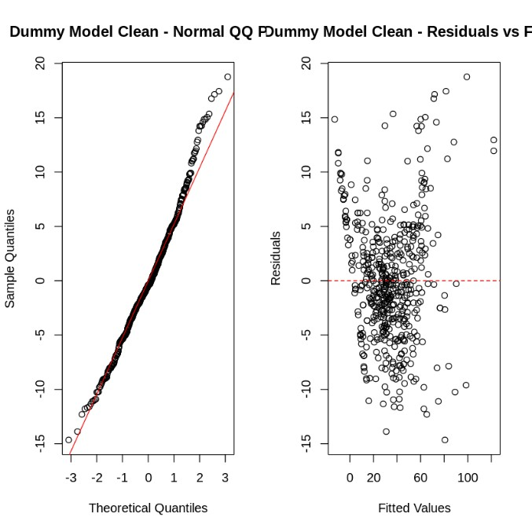
I then printed out each of my entries, along with their predicted values, actual values, and the residuals. I did this for each of my four models. I also wrote some code to get accuracy ranges. I wanted to see how accurate the models were within certain ranges. The code looks like this:
# Accuracy ranges for Dummy_Model_Clean cat("=== DUMMY MODEL CLEAN ACCURACY ===\n")
ranges <- c(50, 25, 20, 10, 7.5, 5) for (r in ranges) {
within_range <- sum(abs(ncaa_dummy_no_outliers$Skill.Points - ncaa_dummy_no_outliers$Predicted_Dummy) <= r) percent_within <- within_range / nrow(ncaa_dummy_no_outliers) * 100 cat("Number of predictions within", r, "points:", within_range, "\n") cat("Percentage of predictions within", r, "points:", round(percent_within, 2), "%\n\n") }

I did this for all my models and got this comparison table:

Accuracy Range | Full Model (%) | Dummy Model (%) | Full Model (Cleaned) (%) | Dummy Model (Cleaned) (%)
±50 points | 99.81% | 100% | 100% | 100%
±25 points | 97.16% | 98.67% | 100% | 100%
±20 points | 96.21% | 96.97% | 100% | 100%
±10 points | 78.60% | 85.61% | 82.50% | 89.33%
±7.5 points | 68.18% | 73.30% | 71.57% | 76.48%
±5 points | 52.84% | 56.25% | 55.47% | 58.70%

The 89.33% accuracy within ±10 points is strong predictive performance.
I decided to see about improving the models even more. Each of my variables had a coefficient along with a significance level. I decided to improve the models even further by removing any of the variables that are not significant. I identified these variables as insignificant:
HC.Moti.1, OC_Moti.1, HC_TD3, OC_TD2, OC_TD3, and DC_TD1. I then printed out a comparison table like this to see if removing those variables made a difference.
Model | Variables | R² | MAE | RMSE | AIC
Dummy Model (Clean) | 33 | 0.932 | 4.39 | 5.65 | 3256.27
Dummy Model (Refined) | 27 | 0.931 | 4.41 | 5.69 | 3251.50

As you can see, using Dummy Model Refined did not actually really improve the model. It has a lower R-Squared, and a higher MAE. My model that consisted of dummy variables with outliers removed was determined to be my best model. These are the coefficients for the model with dummy variables and no outliers:
Variable | Estimate | Std. Error | t value | p-value | Significance
(Intercept) | 83.393 | 2.559 | 32.590 | <0.001 | ***
DevT Impact | -38.170 | 1.990 | -19.182 | <0.001 | ***
DevT Normal | -50.541 | 2.054 | -24.610 | <0.001 | ***
DevT Star | -23.550 | 1.987 | -11.855 | <0.001 | ***
HC_Moti.1 | 0.382 | 0.657 | 0.581 | 0.561
HC_Moti.2 | 2.013 | 0.767 | 2.625 | 0.009 | **
OC_Moti.1 | 0.628 | 1.128 | 0.557 | 0.578
DC_Moti.1 | 3.143 | 0.894 | 3.516 | <0.001 | ***
HC_TD1 | 9.575 | 1.072 | 8.934 | <0.001 | ***
HC_TD2 | 2.715 | 1.106 | 2.454 | 0.014 | *
HC_TD3 | -0.326 | 1.601 | -0.204 | 0.839

OC_TD1 | 3.068 | 0.990 | 3.097 | 0.002 | **
OC_TD2 | 1.862 | 1.481 | 1.257 | 0.209
OC_TD3 | 2.450 | 2.085 | 1.175 | 0.241
DC_TD1 | -1.486 | 2.496 | -0.595 | 0.552
DC_TD2 | 14.250 | 2.556 | 5.575 | <0.001 | ***
DC_TD3 | 13.068 | 2.688 | 4.861 | <0.001 | ***
XP.Penalty | -0.428 | 0.012 | -35.737 | <0.001 | ***
Position_CB | 0.567 | 1.708 | 0.332 | 0.740
Position_DL | -6.448 | 1.596 | -4.040 | <0.001 | ***
Position_K | 0.260 | 3.078 | 0.084 | 0.933
Position_LB | -10.656 | 1.656 | -6.436 | <0.001 | ***
Position_OL | 3.175 | 1.531 | 2.074 | 0.039 | *
Position_P | 0.892 | 2.869 | 0.311 | 0.756
Position_RB | -4.670 | 1.630 | -2.865 | 0.004 | **
Position_S | -2.172 | 1.664 | -1.305 | 0.193
Position_TE | -6.686 | 1.680 | -3.980 | <0.001 | ***
Position_WR | -0.362 | 1.525 | -0.237 | 0.813
Year_FR (RS) | -2.881 | 0.803 | -3.588 | <0.001 | ***
Year_JR | -4.769 | 1.021 | -4.669 | <0.001 | ***
Year_JR (RS) | -2.515 | 0.980 | -2.567 | 0.011 | *
Year_SO | -3.163 | 1.029 | -3.075 | 0.002 | **
Year_SO (RS) | -5.085 | 0.902 | -5.638 | <0.001 | ***
The baseline for the development trait variables is Elite, so Impact, Normal, and Star are all in comparison to it. The baseline for the position variables is QB, so all the other positions are in comparison to how quarterbacks develop. Finally, the baseline for the year variables is FR, so all of the other years are in comparison to how freshmen develop.
It is important to note that some coaching ability coefficients are negative (HC_TD3: 0.33, DC_TD1: -1.49). This does not mean these abilities cause players to lose skill points in the game; rather, these variables were statistically insignificant (p > 0.05) and their coefficients are likely due to random variation in the sample. In practice, coaching abilities can only provide neutral or positive effects on player development. I chose to retain all variables in the final model rather than remove the insignificant ones, as the Refined model (which excluded these variables) did not show meaningful improvement in predictive accuracy. The full model with all coaching abilities provides a more complete picture of the coaching system, even if some individual effects are not statistically significant.

Visualizations
I exported my data from R into a .csv file that I then imported into Tableau. I made two dashboards. The first one focuses on skill points, specifically skill points by player year and actual skill points compared to the model predictions. The second one is a look at MAE by team and development trait.

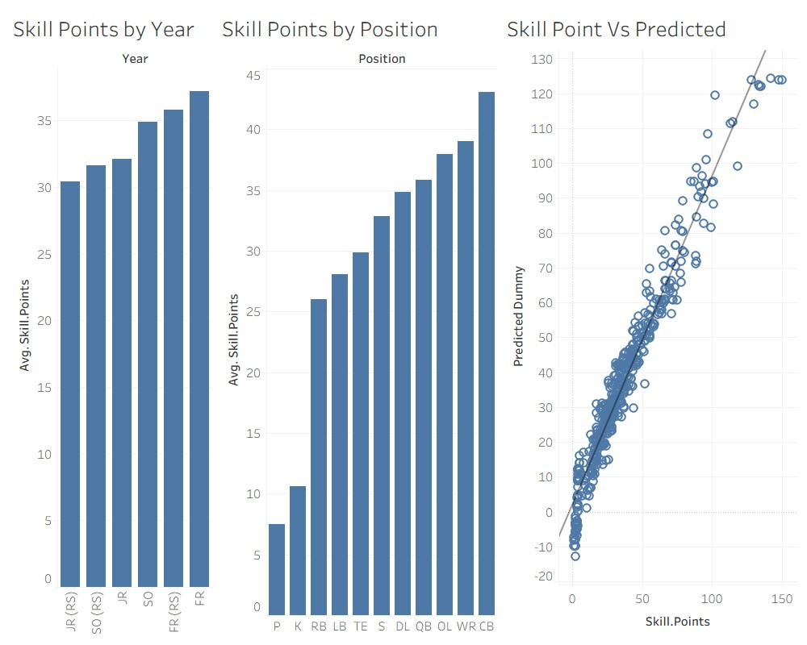
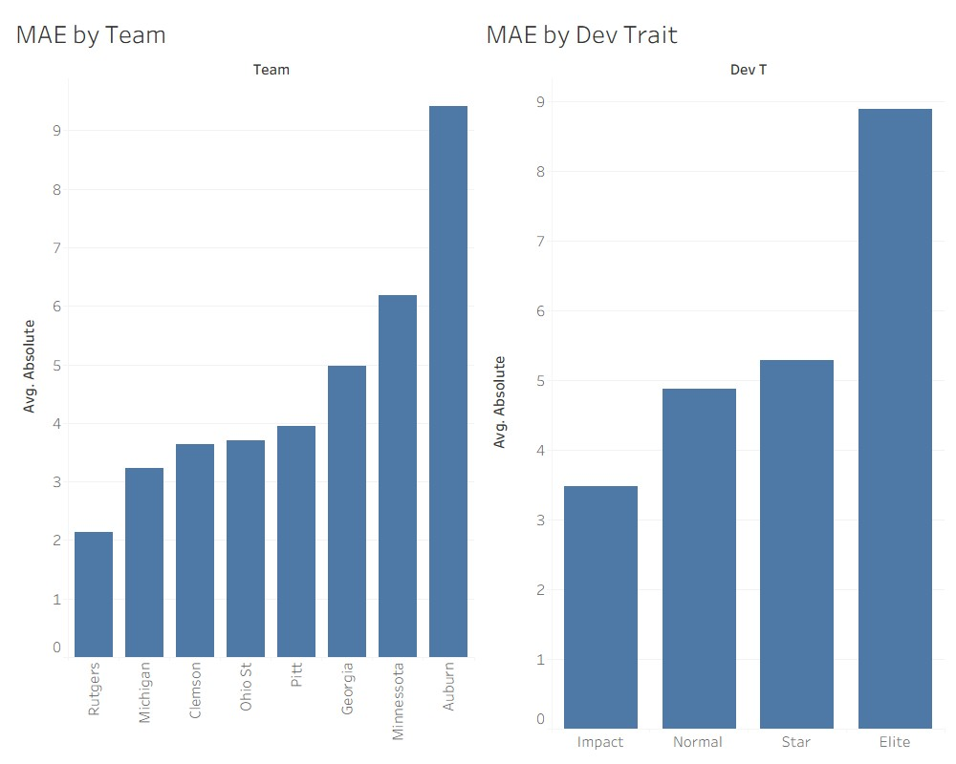
Here you can see that the underclassmen outperform their older counterparts. This is likely due to the fact that there is an available coaching ability (TD_2) to help just the Freshmen and Sophomores. Based just on the graph though, maybe redshirt sophomores are not included in that? Maybe it is just freshmen, redshirt freshmen, and true sophomores that get the boost. We can see what positions earn a lot of skill points and which ones don’t. Punters and kickers definitely struggle while corners and receivers are living in luxury. It is important to note that of all the positions, I have the fewest number of punters and kickers as there are only 2-3 per team. Finally, the skill points vs predicted chart. I am really proud of this as you can clearly see that the model fits well. It falls off a little bit past maybe 60 or 70, but overall, really solid.

When looking at this dashboard, it looks like the data for Auburn is different from the rest, and that is because it is. I actually ran some code to see if all of the data from Auburn should be removed. I found that the MAE actually improved by an entire point, but the R-Squared actually would have gone down. I decided to just keep the Auburn data. It would not hurt to have the model trained on some data that is further down the line. Players who are further into their dynasty may want to use this model as well. It is also no surprise that the Elite dev trait had the highest MAE as it had a small sample size (N = 11). Conversely, it makes sense that Impact would have the lowest MAE as it had the highest number of entries (N= 250).

Web Application
To really top off this research, with the assistance of Claude AI, I built a web application that fellow Dynasty players can use to predict their players’ skill points. The application was built using Streamlit. It uses a Python framework that takes scripts into interactive web applications. This allowed me to take my model and turn it into a user-friendly application that anyone can access simply with a URL link. The app is hosted on Streamlit Cloud. This is a free deployment platform that makes the model accessible to everyone. In the app users input information such as a player’s position, year, development trait, etc. and they immediately receive a skill point prediction. The app also displays numbers about how accurate the prediction will be. It provides a range as well as a likelihood for the prediction.
Not only is this great because everyone in the community can have access to the model, but by users using this tool, they can actually help to train the model even further by providing more entries for the dataset that the model is trained on. With each submission, users are requested to input the actual amount of skill points their player receives in the offseason.
Granted, not everyone who uses the model will be on the Training Results screen, but it is still a cool function. All of this data is stored in a Google Sheets database through Google Cloud’s API system. This allows for a secure connection between the application and the database. This ensures I will not have to manually input any more information on my end. The Google Cloud service account credentials are stored as ‘secrets’ in Streamlit Cloud rather than in the code itself.
This keeps the database protected while allowing the app to function correctly.
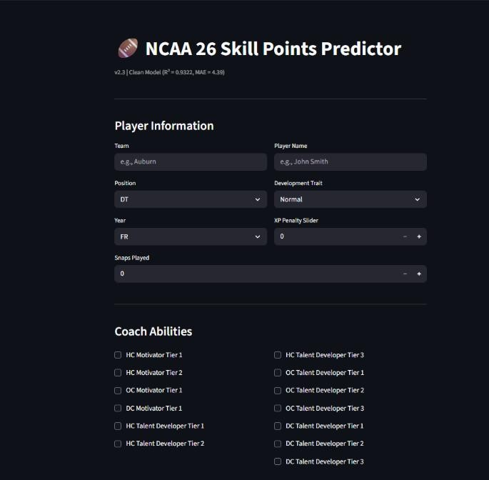
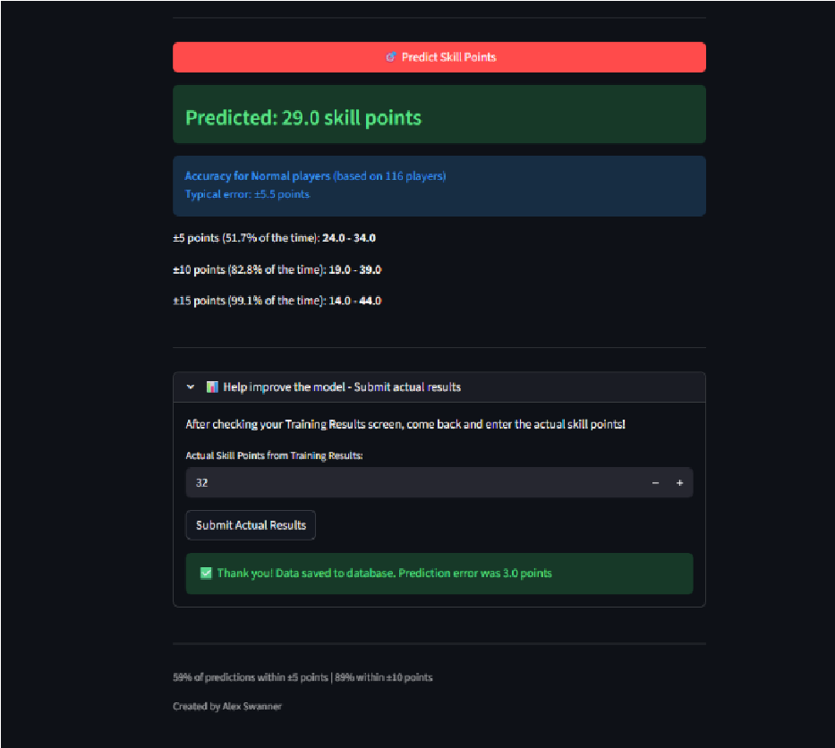
This web app approach transforms the project from a one-time analysis into an evolving system. As more and more users take advantage of the app, the dataset will grow well beyond five-hundred-six. With each significant increase in the dataset, I can rerun my models to train them even better. This creates a sort of feedback loop where users will be rewarded for using my application with an even better model.

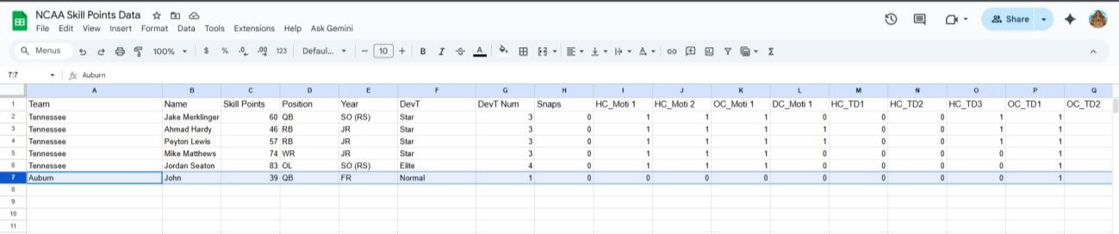

Conclusion
The Training Results screen is a really pivotal part of the offseason. You get to manually develop your players; this gives you a lot of flexibility with molding your team into a powerhouse. Understanding how many skill points each of your players will have to work with can give you a competitive advantage over other users and computer-controlled teams. The model I built is strong and accurate with an R-Squared of .932 and an MAE of 4.39.
This model is not perfect; it has its limitations. Some complex variables such as additional coaching abilities were omitted. My data pool needs further improvement as I am lacking Elite players, punters, and kickers. Building upon this data pool could train my model to be increasingly accurate. I intend to improve this model by adding more players to the data set.
Moving beyond this I look forward to seeing increases in my dataset from other users in the NCAA 26 community. As players use the application, the model will continue to evolve and improve. This approach has the potential to provide some new and in-depth insights that I could not have realized alone, at least not in a short amount of time.
The complete project, including all code, data, and documentation is available on GitHub at:
https://github.com/alexswannerr/NCAASkillPointsResearch
Link to Web App: https://ncaaskillmodel.streamlit.app/

AI Assistance Disclosure
This research was conducted with the assistance of generative AI tools, specifically Claude AI
(Anthropic) and ChatGPT (OpenAI). These tools were used to support R code development,
Python application building, debugging, and deployment guidance.

22

